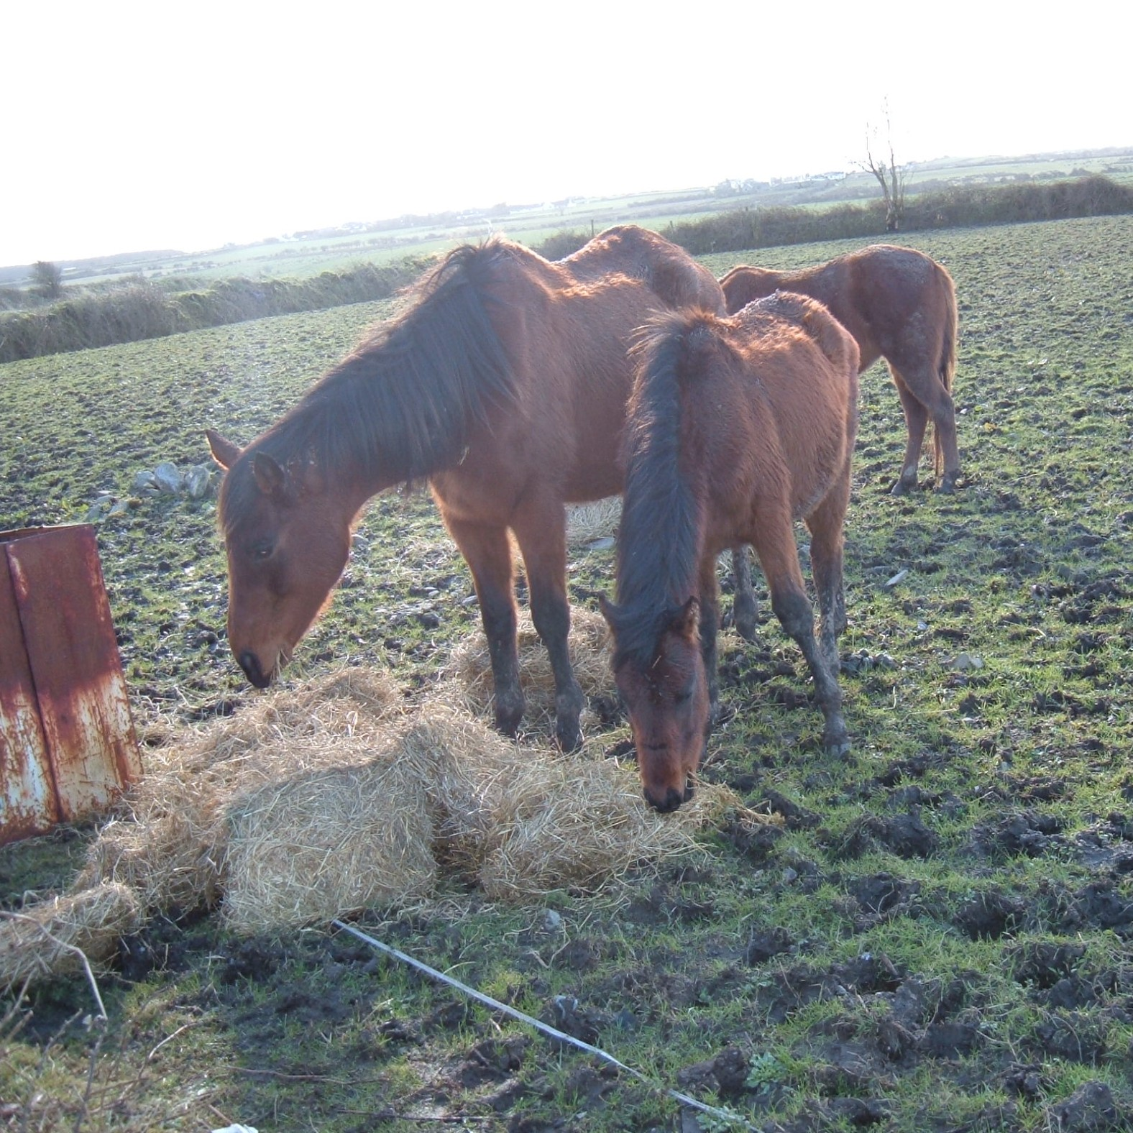
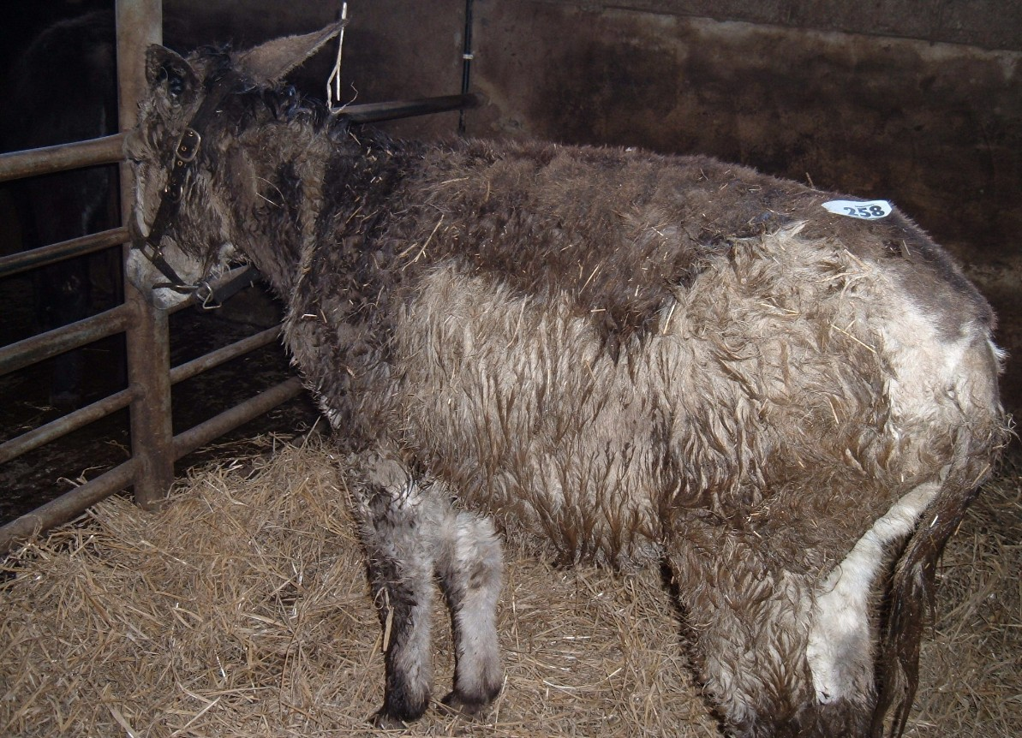
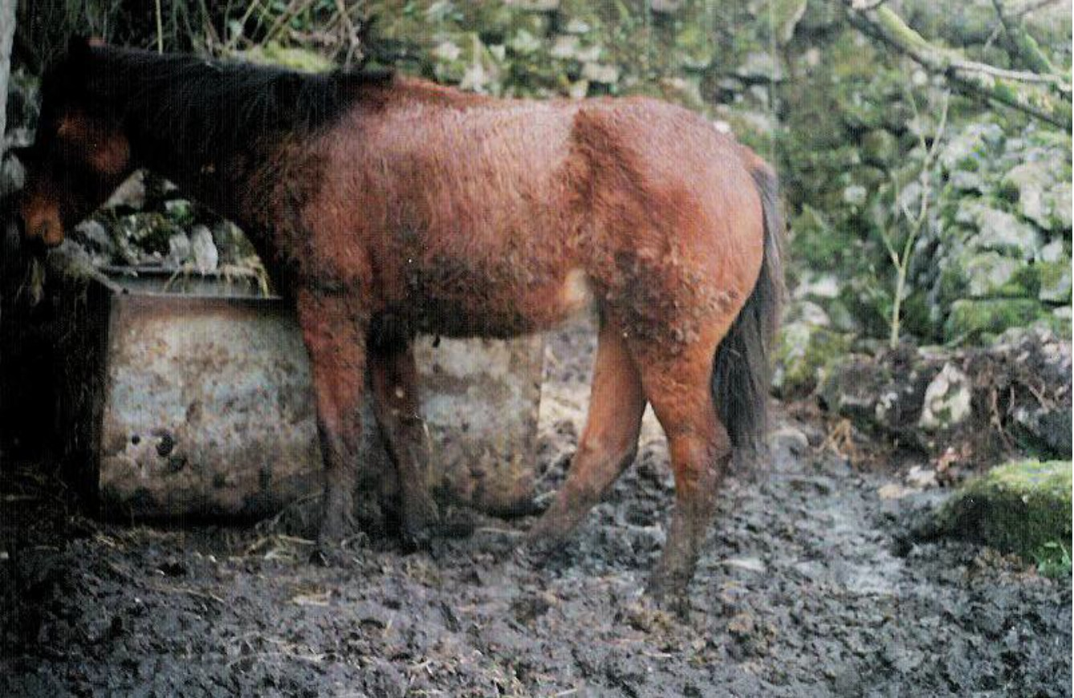
A typically miserable, wet, cold, donkey presented for sale at a mart 2005. The Donkey Sanctuary insisted on the straw bedding!

Animals are commonly left for hours without food, water or bedding both pre and post sale
Above: Horses starving in a field near Ballina 2005

Right: This yearling foal had been in these conditions for 5 months winter 2004
Copyright © 2007 Sathya Sai Sanctuary

